**BUG REPORT**

**Date**: 01-09-2023

**Reported by**: Tasnim Ferdawsh

**Summary:** system calculate ticket fare when departing date more then 90

**Descripton:**

When given input between 500 miles than the system show me the output with counting seat class. Which will not ne calculate and that is not expected.

**Steps to reproduce**:

* Go to application
* input : distance=500
* enter departure date: 1
* select Seat class =business
* click calculate button

**Expected Result:**

* system should display an error messege

**Actual Result**: the cost is $150

**Attachments:**

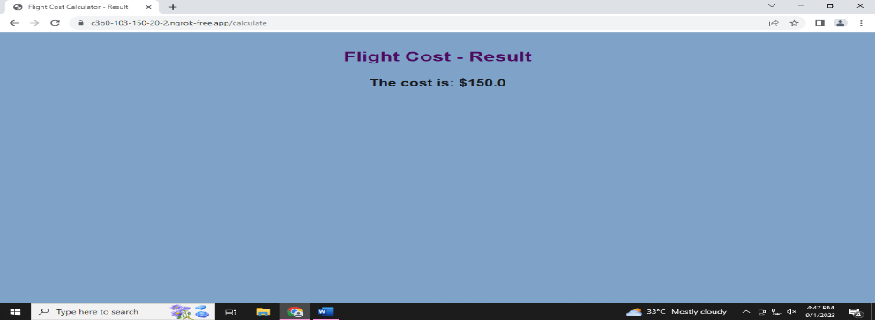

**Environment:**

* Operating system: Windows 11
* Browser: Chrome , version:  **116.0.5845.141 (Official Build) (64-bit)**

**Priority: high/medium/low=how important of bug**

**Severity: major/moderate/low=Impact of this bug on application**